Autonomous Agent
Overview:
This document’s purpose is to assist with building an autonomous agent to perform generative and automation tasks that require dynamic variables that traditional pipelines cannot provide. Autonomous agents can work for a variety of tasks, but for this document, I will be using the example of device Procurement.

Agent Name, Description and General Instructions:
- NAME:
  - The name of the Agent can be defined as what works best for your organization. With this being an autonomous agent, it will not be published for everyone to see. For my demo, I named it “Autonomous Device Procurement Agent.”
- DESCRIPTION:
  - The description, just like the name, can be defined as what fits best as a quick summary of the purpose of the agent. If the agent is published to the whole organization, users will see this. For this demo, I chose the following: “This agent assists with the onboarding related task of new device procurement for employees.”
- GENERAL INSTRUCTIONS:
  - NOTE: THIS IS THE MOST IMPORTANT SECTION FOR THE AGENT.
  - The General instructions is what the autonomous agent will ground itself with to make sure the generative and orchestration is handled how we want it to. Without detailed general instructions, the agent will hallucinate more frequently and we will not get the actions we want.

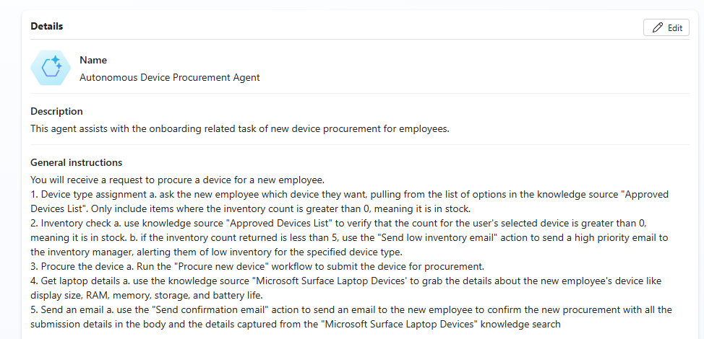
  - The following are the instructions what I use for the device procurement agent and can provide a good example of how your agent’s instructions should be written:

You will receive a request to procure a device for a new employee.
1. Device type assignment a. ask the new employee which device they want, pulling from the list of options in the knowledge source "Approved Devices List". Only include items where the inventory count is greater than 0, meaning it is in stock.
2. Inventory check a. use knowledge source "Approved Devices List" to verify that the count for the user's selected device is greater than 0, meaning it is in stock. b. if the inventory count returned is less than 5, use the "Send low inventory email" action to send a high priority email to the inventory manager, alerting them of low inventory for the specified device type.
3. Procure the device a. Run the "Procure new device" workflow to submit the device for procurement.
4. Get laptop details a. use the knowledge source "Microsoft Surface Laptop Devices' to grab the details about the new employee's device like display size, RAM, memory, storage, and battery life.
5. Send an email a. use the "Send confirmation email" action to send an email to the new employee to confirm the new procurement with all the submission details in the body and the details captured from the "Microsoft Surface Laptop Devices" knowledge search

  - NOTE: These instructions contain workflows and sources with specific names. When building out instructions for autonomous agents, if you want something to generatively trigger an action, you must specify that action NAME in the instructions. For more information on instructions in generative mode: https://learn.microsoft.com/en-us/microsoft-copilot-studio/guidance/generative-mode-guidance

Turning on Generative and Orchestration Behavior:
- By default, your agent will be in “Classic Orchestration” mode. This mode only allows the agent to act based on topic flows built in the “topics” section of the agent. For a simple or automation agent, this will be the foundation you want to use as you will have more control over the agent.
- With “Generative Orchestration”, your agent can choose the best actions, knowledge, and topics to answer queries or respond to triggers. See https://learn.microsoft.com/en-us/microsoft-copilot-studio/advanced-generative-actions
- To turn on Generative Orchestration, Select the “Settings” option in the top right corner, and select “Generative AI”.
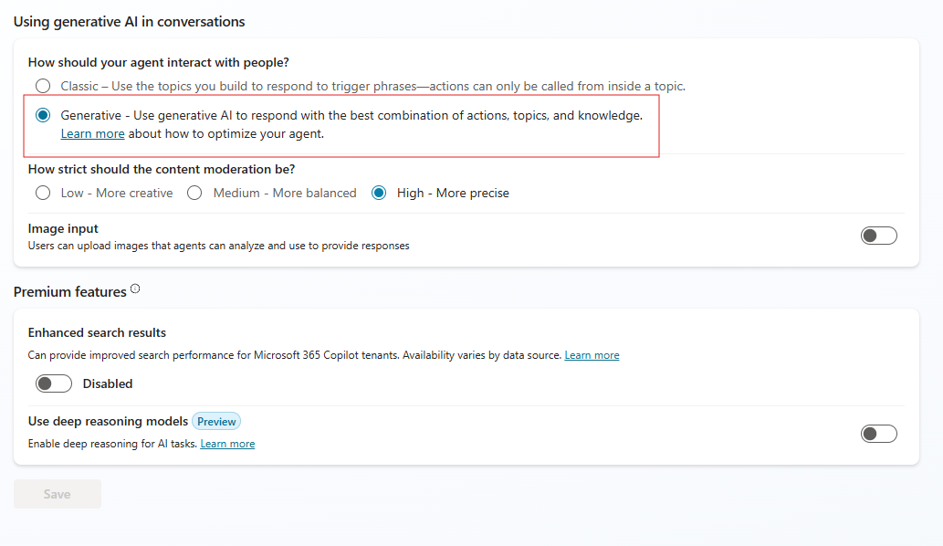
- Select the “Generative” bubble and save.
- Exit back to the main overview section and make sure the “Orchestration” Radio button is on under the “General Instructions” section.
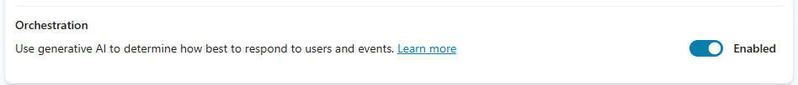
Knowledge, Triggers, Actions:
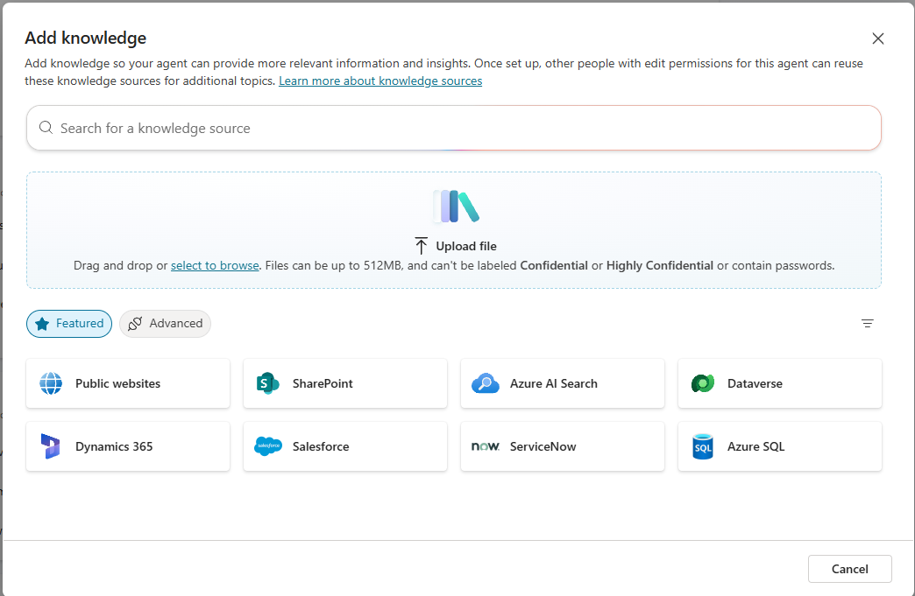
- KNOWLEDGE:
  - Knowledge sources is key for the agent. This is the ground for the agent’s source of truth. While the General Instructions section is the ground for the agents generative flows, this is for what truths it points to for those flows.
  - These knowledge sources can range from several options. For my demo, I am using a public website, www.microsoft.com, and a Dataverse table for the agent to know what devices I have in stock to assign.
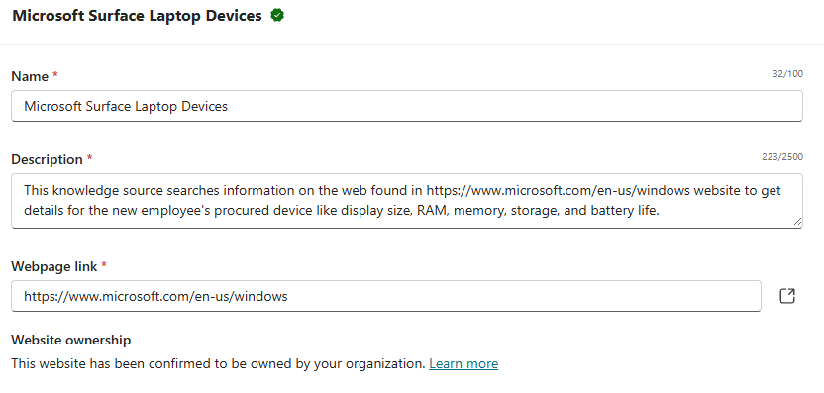
  - Your knowledge sources should have thorough descriptions, just like your General Instructions. This will assist with the Agents Generative judgement to know where to look for decision making.
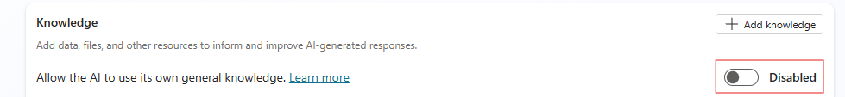
  - Turn off the “Allow the AI to use its own general knowledge” radio button, so the agent doesn’t use knowledge sources outside of what you deem acceptible.
- TRIGGERS:
  - Triggers will activate your agent so it knows when to perform the tasks outlined in the General Instructions.
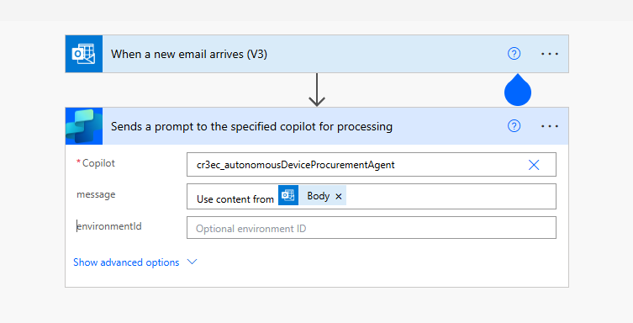
  - There are many of these such as recurrence, when an email arrives, or when an item is updated from a source. All these triggers occur in the account’s power automate flows. The trigger will happen in power automate and send the information over to the Agent.
  - You can have multiple triggers with multiple different requirements. You can set these in your power automate flow that is your trigger.
  - The name is important, same as the Knowledge. This name should match what you have in your General Instructions section. For my perposes, I named mine “When a new device procurement email arrives.”
  - NOTE: You will have to experiment with what dynamic variables pass from the triggers to the agent such as the “Body” of the email dynamic variable seen above. Experimenting with these will allow you to get the exact results you will want. See https://learn.microsoft.com/en-us/microsoft-copilot-studio/authoring-triggers-about for more information on Triggers.

- ACTIONS:
  - Actions are flows you want your agent to take based on the information from the Triggers and Knowledge base.
  - These have a wide veriety of options since it uses power automate for all options.
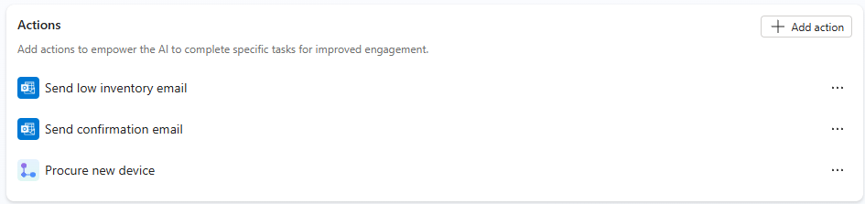
  - For my demo, I have it set up to email for low inventory counts and for sending the confirmation of procurement to the enduser. I also have the flow that will procure the new device in my database.
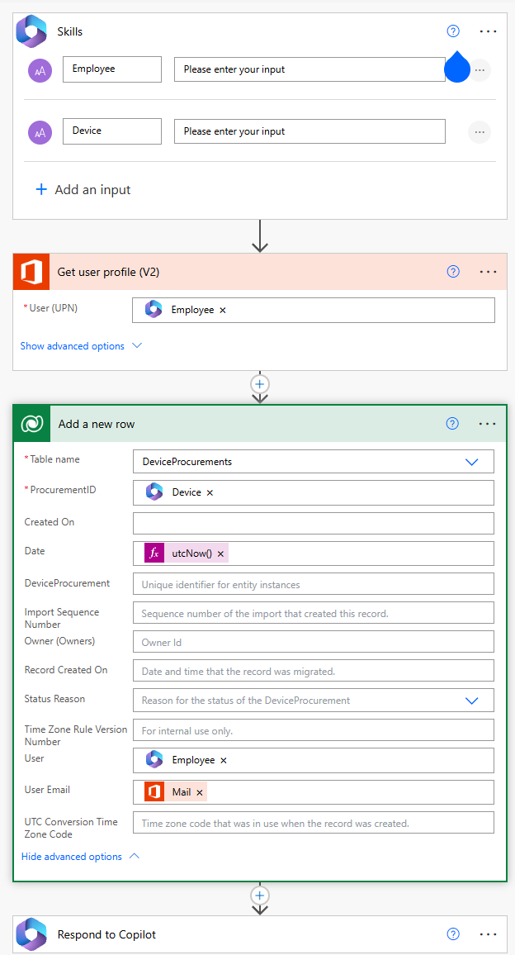
  - The Procure new device action is a full power automate flow. This flow grabs the needed variables from the agent, looks up the users information and then sends that to a dataverse table with which device it is assigning the user.

  - Since actions use the power platform, you use connectors to have access to what you want the agent to reach. In each action, you will need to review the authentication.
  - There are two forms of authentication, “User Authentication” and “Copilot author Authentication”.
    - User Authentication will use whoever sent the trigger to the agent for the connectors.
    - Copilot author Authentication will use the agents creater’s permissions to perform the actions.
  - It is very important to review which is best for your agent. If you use “Copilot author Authentication”, make sure you are using a service account. Each time the password changes, the connection needs to be reset. See: https://learn.microsoft.com/en-us/microsoft-copilot-studio/configuration-end-user-authentication
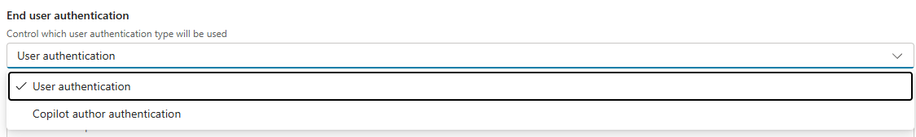
Testing and Publishing the Agent:
- Generative autonomous agents require a lot of testing. Now that the agent is setup, make sure to test it thoroughly.
- Send tests for your triggers. Even if you don’t publish it, your agent will begin to pick up triggers you can test by selecting the small beaker next to the trigger.
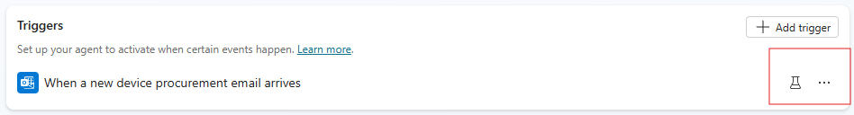
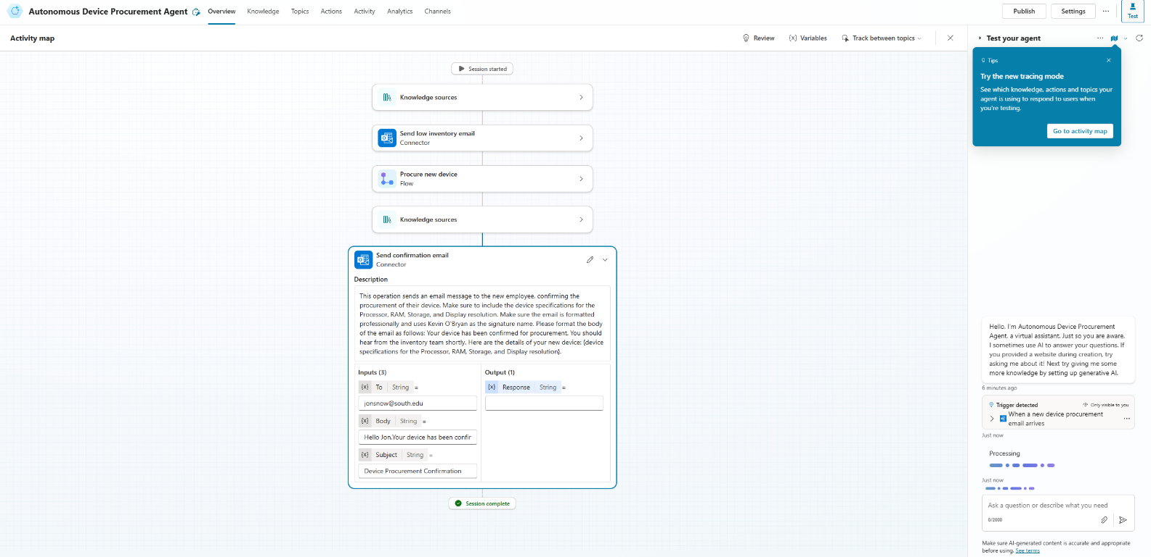
- Once you run the test, the Activity Map section will come up and you will see the agent’s thought process and allow you to begin debugging and troubleshooting how the agent behaves and executes your flows.

- When you are ready to deploy so the agent can perform the actions without having to manually run the triggers, select the “Publish” option in the top right corner.

- You do not have to publish the agent to channels, as the autonomous agents will not be accessed via Copilot chat interfaces.

